10th April 2017

Newcomer impresses in WTCC Race of Morocco Season Opener

The Argentinian Esteban Guerrieri scored his maiden FIA World Touring Car Championship victory with the Opening Race in Marrakech, while the top spot on the main Race, which carries additional Championship points went for the veteran Portuguese Honda driver Tiago Monteiro. This placed Monteiro at the head of the Championship and a new bid to world title glory following the first weekend of the season. Once again the Championship has the Japanese Tyre manufacturer YOKOHAMA as exclusive tyre supplier.

Guerrieri started the Opening Race second on the grid but capitalised on Tom Coronel’s fading brakes to win ahead of Polestar Cyan Racing’s Thed Björk and local hero Mehdi Bennani. Norbert Michelisz followed his Honda team-mate Monteiro home in the Main Race, which is longer and offers more points this season.

Nestor Girolami took third for the factory Volvo Polestar squad, which is level with Honda in the Manufacturers’ standings heading to the next race in Italy.

With eight potential world champions in action, this season’s world championship is already shaping up to be the most open in nearly a decade, while Guerrieri’s victory points to a bright WTCC future for the talented Argentine, once a rival of Lewis Hamilton and Sebastian Vettel in Formula 3.

Other notable performances came from rookie racer Aurelien Panis and Ryo Michigami, who took their first WTCC point with P10 in the Opening Race and Main Race respectively. After Guerrieri secured the WTCC Trophy laurels in the Opening Race, Tom Chilton secured the Main Race victory when on-the-road winner Bennani received a two-second penalty for a collision with Nicky Catsburg, which dropped him from fourth to sixth overall and from first to second in the classification for privateer racers.

Current Overall Standings

1 MONTEIRO Tiago Portugal 43
2 MICHELISZ Norbert Hungary 36
3 CATSBURG Nicky Netherlands 28
4 BENNANI Mehdi Morocco 26
5 GUERRIERI Esteban Argentina 25

The next race will be held in Monza, Italy from 28-30th April 2017.

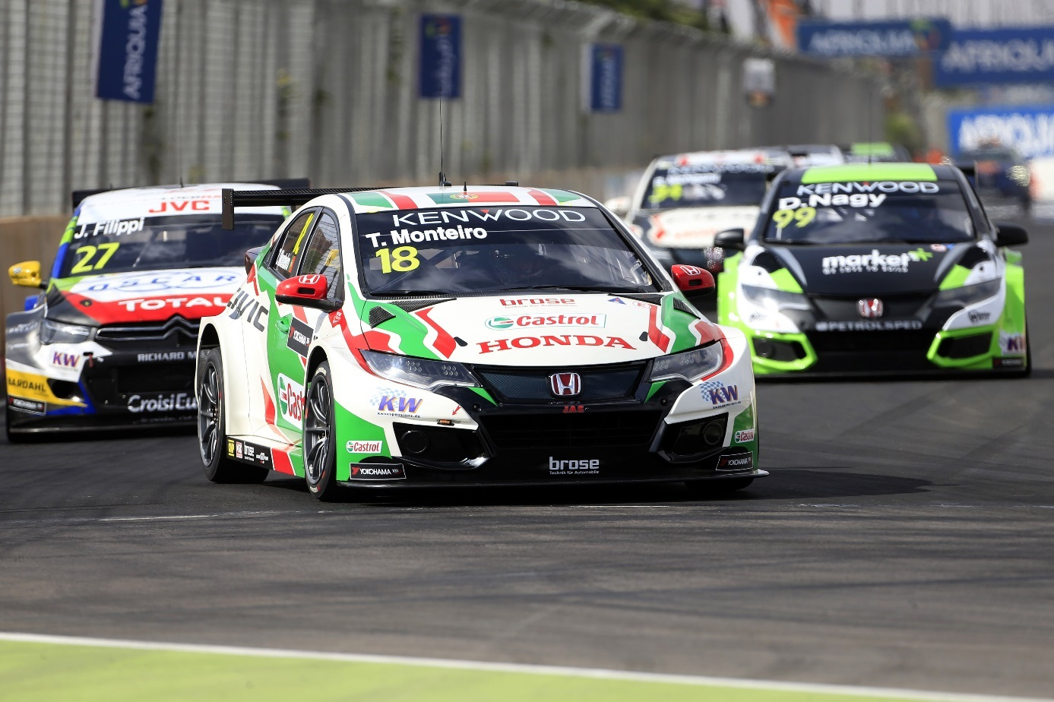
Monteiro Leads the Championship photo by Paulo Maria DPPI

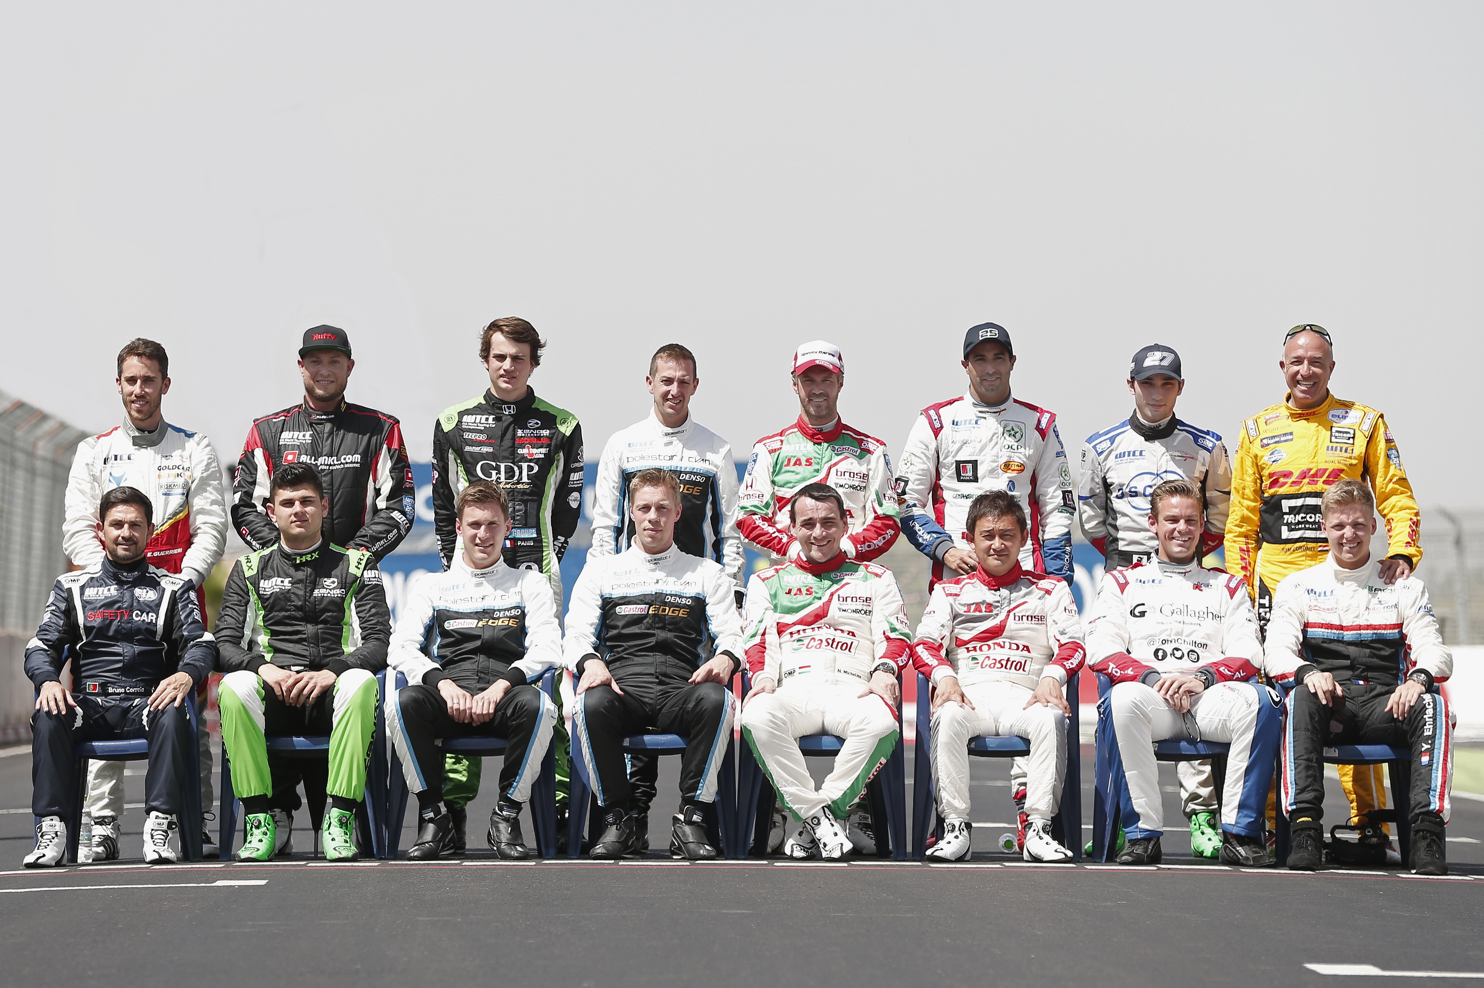
2017 FIA WTCC Drivers photo JM Le Meur DPPI

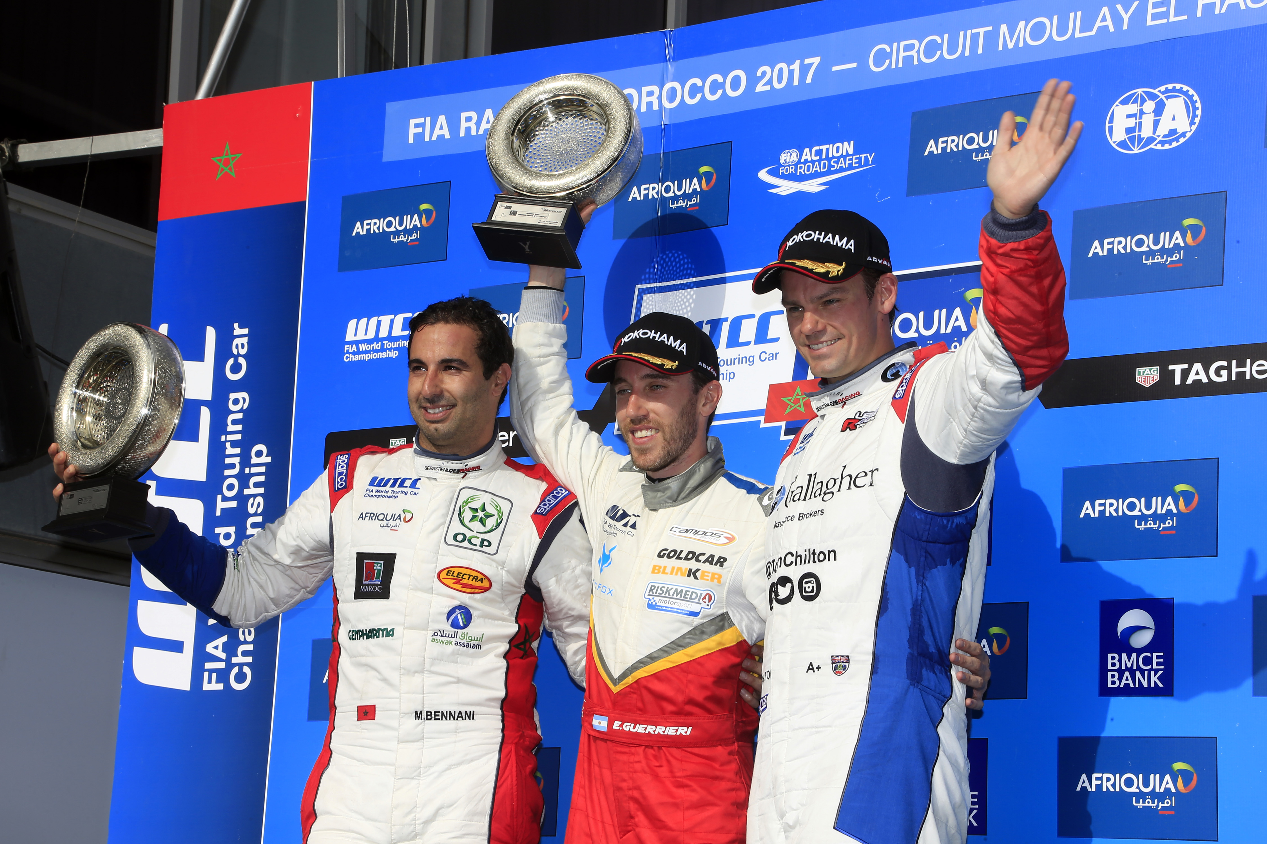
Newcomer Esteban Guerreri Impresses in Morocco

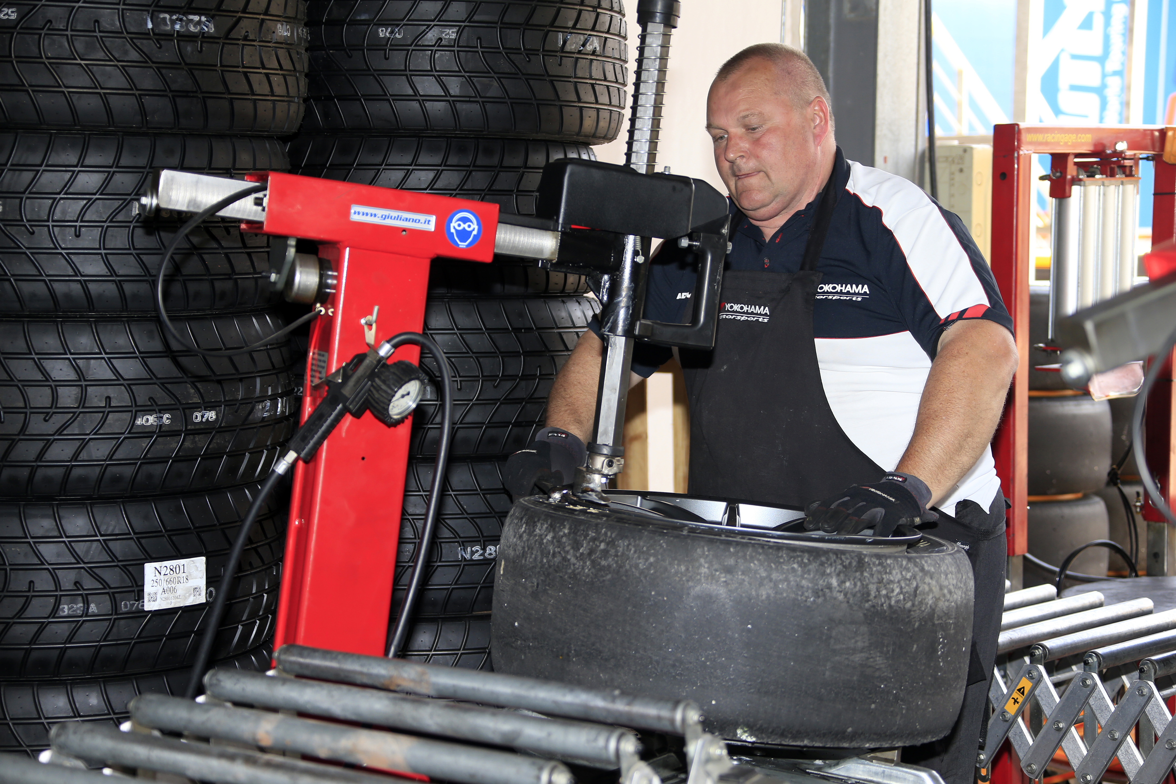
YOKOHAMA Motorsports Team member mounting the race tyres photo Paulo Maria DPPI

